COMPUTER NETWORKS
PRACTICAL FILE
(CO 306)



NAME – PRINCE PIYUSH
ROLL NO - 2K16/CO/236
BRANCH - CO
BATCH - A4(GROUP G1)
SUBJECT – COMPUTER NETWORKS
FACULTY – MS. SAPNA SHARMA

Experiment – 1

AIM- To find out the class to which ip address belong..

Description -
Internet Protocol hierarchy contains several classes of IP Addresses to be used efficiently in various situations as per the requirement of hosts per network. Broadly, the IPv4 Addressing system is divided into five classes of IP Addresses. All the five classes are identified by the first octet of IP Address.
- Class A: The first class or Class A IP address has its first octet in the range 1-127 since the first bit is always zero.
- Class B: The second class or Class B IP address has its first octet in the range 128-191.
- Class C: It contains the first octet in the range of 192-223.
- Class D: The first octet is in the range of 224-239.
- Class E: This class of IP addresses are just meant for research purpose and have the first octet in the range 240-255.

Code -
#include <bits/stdc++.h>

using namespace std;

int main(){
char ip[15];
cout<<"Enter IP address: ";
cin>>ip;

stringstream sin(strtok(ip,"."));
int x;

sin>>x;
cout<<"Your IP address is of Class ";
if (x >= 0 && x <128){
cout<<'A';
}else if(x<192){
cout<<'B';
}else if(x<224){
cout<<'C';
}else if(x<240){
cout<<'D';
}else if(x<=256){
cout<<'E';
}else{
cout<<"Wrong IP";
}
cout<<'.'<<endl;
return 0;
}
Output –

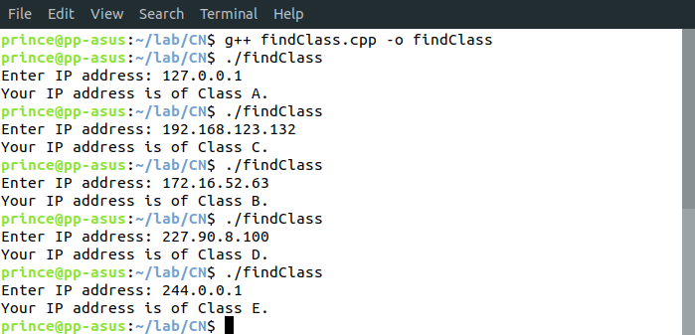
Learnings – We learnt about the different classes of IP address and how they are represented. We also learnt how to distinguish one class of IP address from the other based on the representation.

